**Tutorial 7: Attribute Binding**

Attribute binding is when we bind dynamic values to an **HTML** attributes.

Make sure **Tutorial 6** is complete to be able to move on to this tutorial or clone the [vue3-firebase-course](https://github.com/younggrasshopperza/vue3-firebase-course) repository and go to branch called **Tutorial-6**.

In the **index.html** file, make sure the **body** tag has the below code:

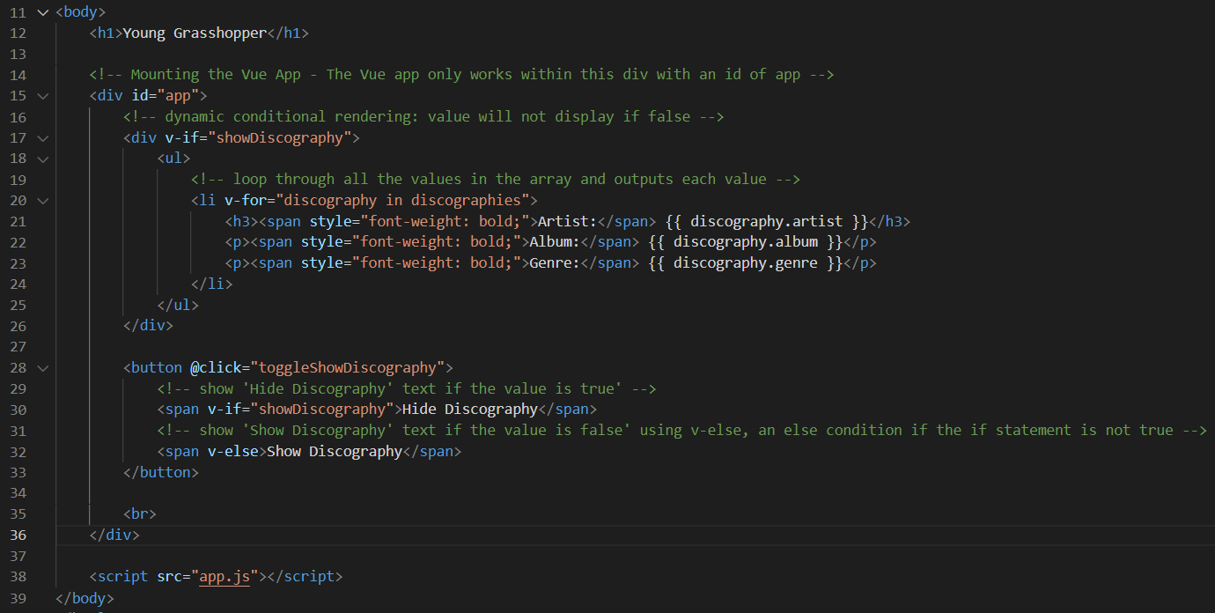

In the **app.js** file, make sure the code looks like the below:

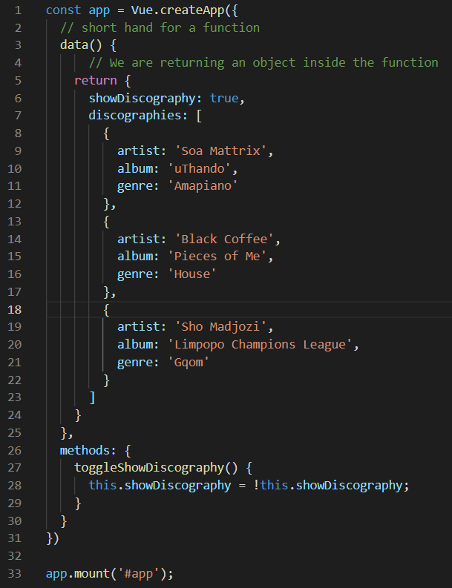

**Step 1:** In the **app.js** file, create a data property called **url** and with a value of any website link.

Look at the example below (**Line 6**):

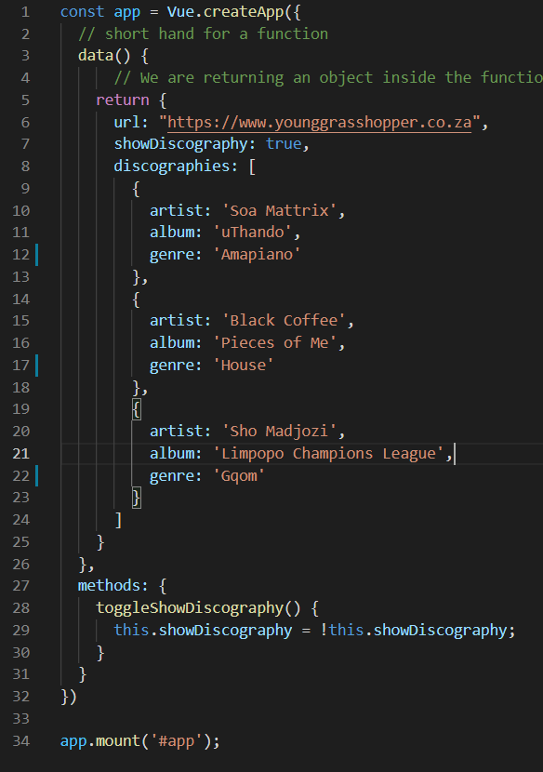

In the **index.html** file, create an anchor tag that binds the **href** with the **url** data property from app.js file that opens the website on a new tab. There are two ways type out the data binding:

v-bind:href="url"

or

:href="url"

Look at the example below (**Line 17 and 21**):

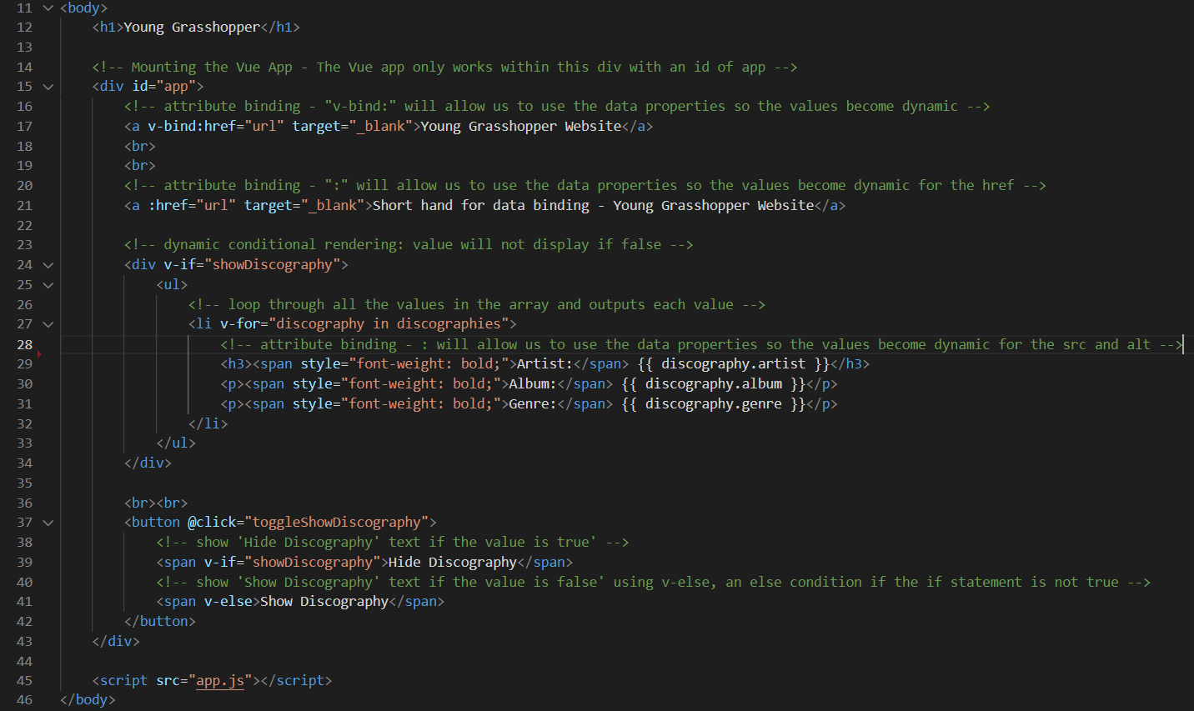

Click on the hyperlinks to view the website on a new tab.

**Step 2:** Create a folder called assets and insert 3 album photos.

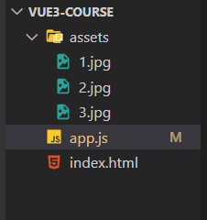

In the **app.js** file, in the **array of objects** called **discographies**, create an additional **key-value pair** for the images with the **key** called **img** and values having the file path to the image in the assets folder.

Look at the example below (**Line 13, 19 and 25**):

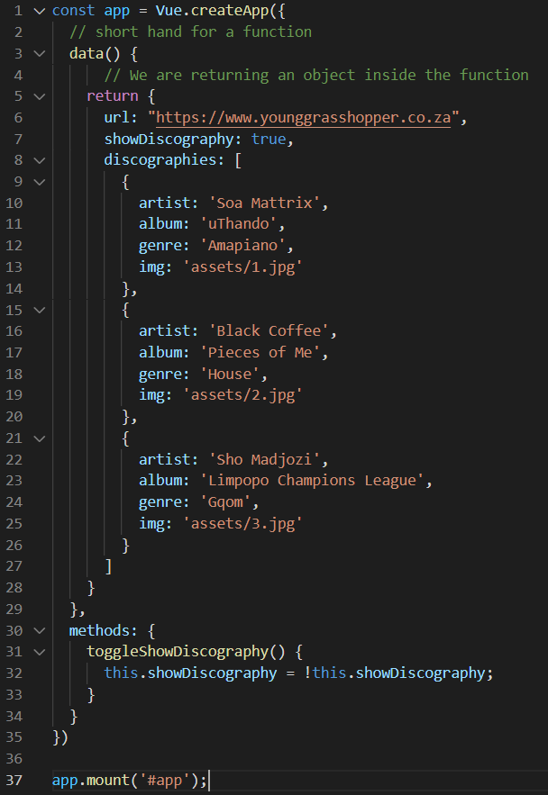

In the **index.html** file, include an **image tag** and bind **src** attribute to the **data property** to the image key in the object. Bind the **alt** attribute.

Look at the example below (**Line 29**):

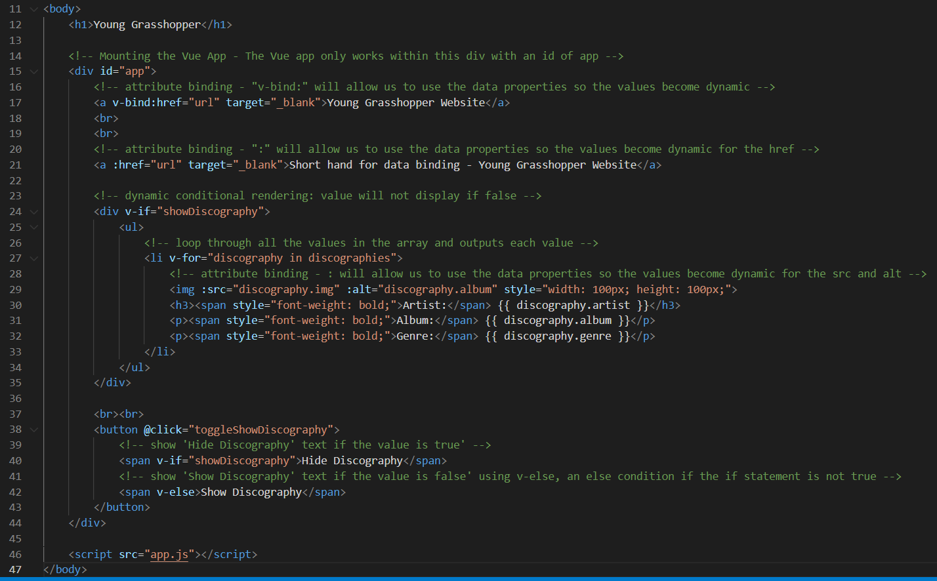

**Output:**

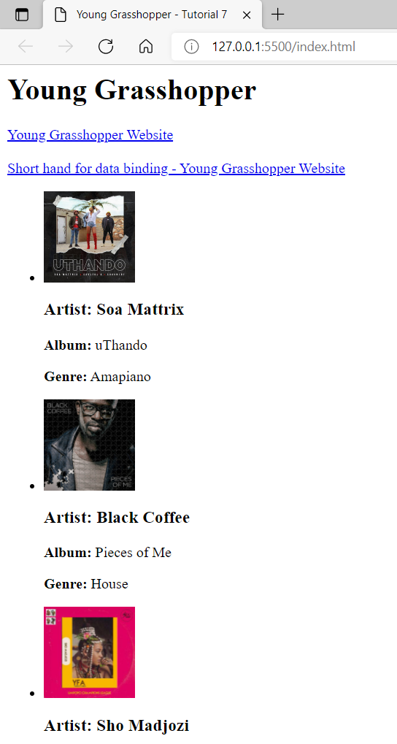

**You can view the code snippets from the** [**vue3-firebase-course**](https://github.com/younggrasshopperza/vue3-firebase-course) **repository under the Tutorial-7 branch.**